Practical 19 :

interface NewShape{

    void draw();

}

interface Circle  {

    void getRadius();

    int radious=10;

}

class NewCircle implements Circle,NewShape{

    public void draw() {};

    public void getRadius()

    {

        System.out.println(radious);

    }

}

class ExtendInterface extends NewCircle

{

    public static void main(String args[])

    {

        NewCircle nc=new NewCircle();

        nc.getRadius();

    }

}

Output :

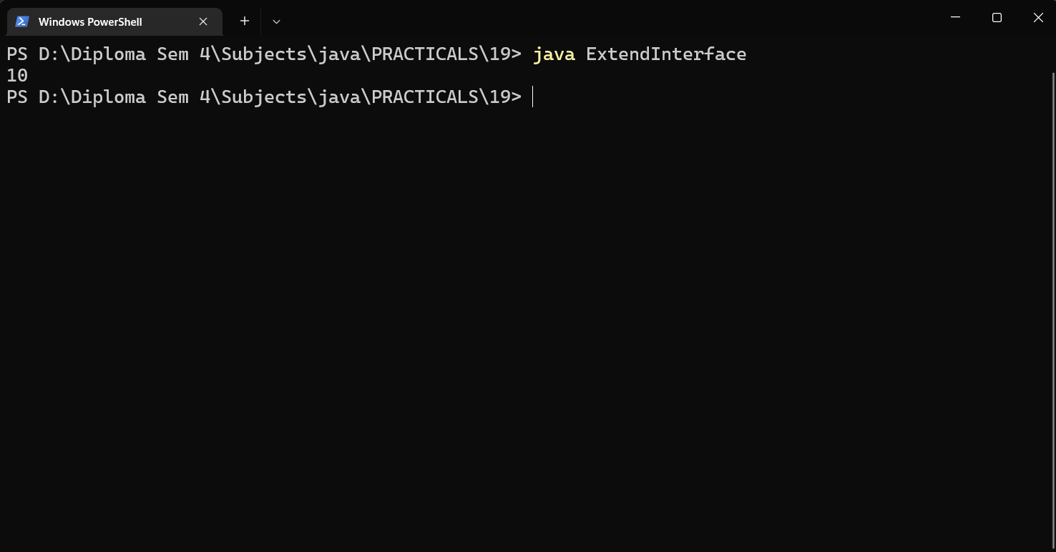

Code :

import java.io.FileNotFoundException;import java.util.Scanner;

interface Area{

    double area(double a,double b);

}

class Circle implements Area{

    public double area(double a ,double b){

        return 3.14\*a\*b;

    }

}

class Rectangle implements Area{

    public double area(double a, double b){

        return a\*b ;

    }

}

public class Q2 {

    public static void main(String[] args) {

        Circle c = new Circle();

        Rectangle r = new Rectangle();

        Scanner sc = new Scanner(System.in);

        System.out.print("Enter the Length :");

        double a = sc.nextInt();

        System.out.print("Ennter the width/base :");

        double b = sc.nextInt();

        System.out.println("Area of Rectangle is : "+r.area(a, b));

        System.out.println("Area of Circle is : "+c.area(a, b));

    }

}

Output :

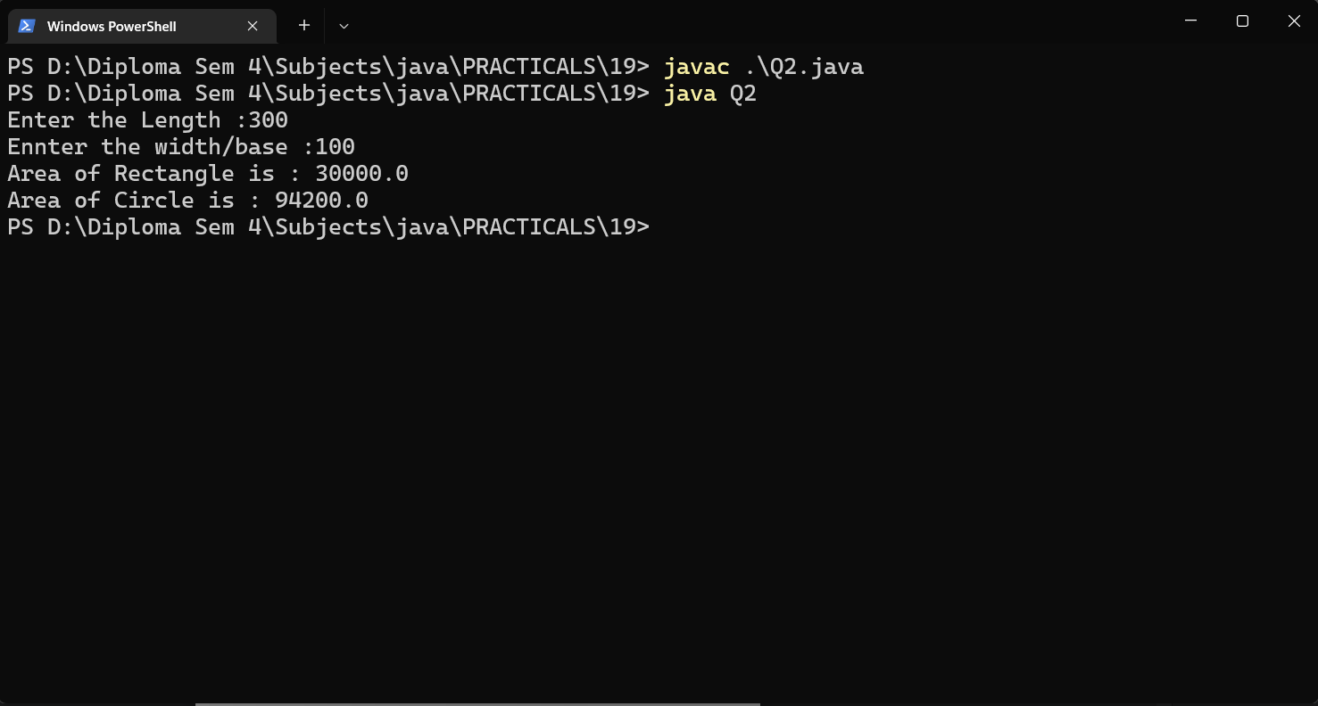

Code :

interface Pet {

    public void test();

}

class Dog implements Pet {

    public void test() {

        System.out.println("Interface Method Implemented");

    }

    public static void main(String args[]){

         Dog p = new Dog();

         p.test();

    }

}

Output :

